AI-AgroBot Documentation

1. Title
AI-AgroBot: An AI Powered Agricultural Assistance System Using Natural Language Processing

2. Project Statement
Agriculture is the backbone of many economies, but farmers often face challenges such as lack of timely crop guidance, difficulty in identifying plant diseases, and limited access to real-time market price information. Many farmers rely on traditional knowledge or delayed expert consultation, which may reduce productivity and increase losses.
The objective of the AI-AgroBot project is to develop an intelligent agricultural assistance platform that helps farmers obtain instant guidance related to crop selection, disease detection, and market prices. The system uses Artificial Intelligence (AI), Machine Learning (ML), and Natural Language Processing (NLP) to understand farmer queries written in natural language and provide accurate recommendations.
By integrating modern technologies with agriculture, AI-AgroBot aims to make farming information easily accessible, improve crop productivity, and assist farmers in making better decisions.

3. Outcomes
The expected outcomes of the AI-AgroBot system include:
- Providing farmers with instant crop advisory based on their queries.
- Detecting plant diseases using image analysis.
- Delivering real-time market price information for crops.
- Allowing farmers to ask questions in natural language through an AI chatbot.
- Improving farming productivity by giving accurate recommendations.
- Making agricultural knowledge easily accessible through a web platform.

4. Technology
The AI-AgroBot system uses modern web technologies along with artificial intelligence tools.
Frontend
- HTML
- CSS
- JavaScript
- Jinja2 Templates
Backend
- Python
- Flask Web Framework
Artificial Intelligence / Machine Learning
- TensorFlow / Keras
- Image classification models for plant disease detection
Natural Language Processing
- NLP models for understanding farmer queries
- Text preprocessing and intent recognition
Database
- SQLite / MySQL (for storing user data, queries, and results)
Other Tools
- Git for version control
- Python libraries such as NumPy and Pandas

5. Modules to be Implemented
The AI-AgroBot system consists of several functional modules.

1. User Authentication Module
Allows users to register, login, and manage their profiles securely.

2. Crop Advisory Module
Provides recommendations about suitable crops, soil conditions, fertilizers, and farming techniques based on user queries.

3. Plant Disease Detection Module
Farmers can upload images of plant leaves, and the system analyzes the image using a trained machine learning model to detect possible diseases.

4. Market Price Module
Displays the latest market prices of crops to help farmers make better selling decisions.

5. NLP Chatbot Module
Allows farmers to interact with the system using natural language questions. The chatbot processes the query and provides relevant responses.

6. Data Management Module
Stores user queries, results, and system information in the database.

6. Architecture Diagram
The system follows a client-server architecture.
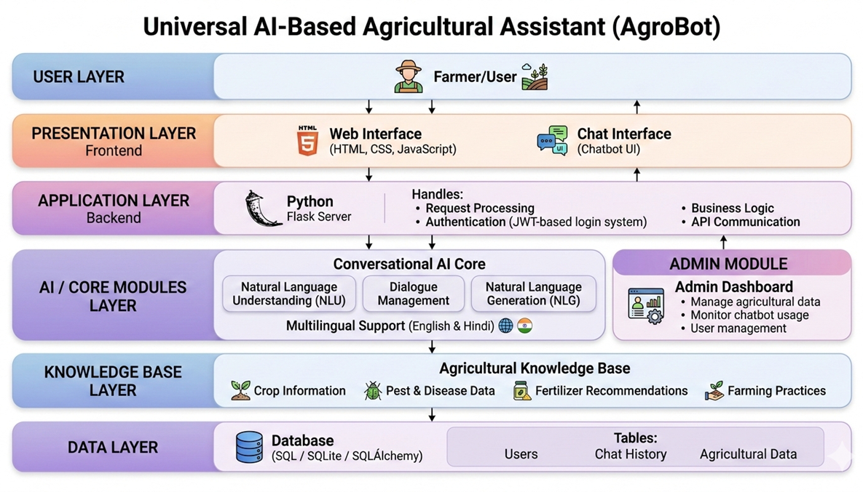

7. Database Schema
The system database stores information related to users, queries, and results.
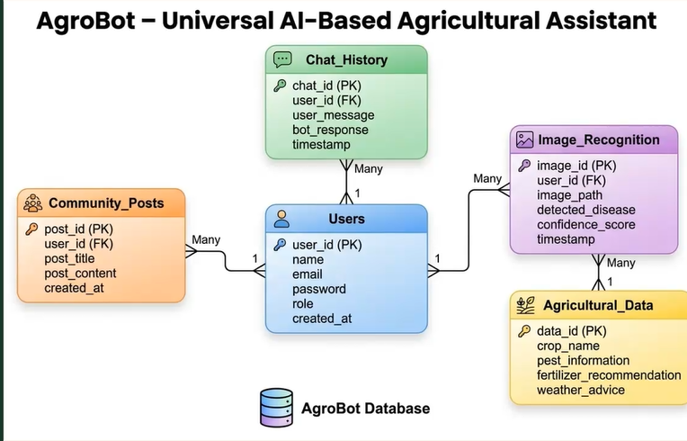

8. Feature Enhancement
Future improvements can make the system more powerful.
- Voice-based interaction for farmers who cannot type.
- Support for multiple regional languages.
- Integration with live agricultural market APIs.
- Weather-based crop advisory.
- Mobile application version of AgroBot.
- Real-time agricultural news and alerts.

9. Conclusion
AI-AgroBot demonstrates how artificial intelligence and natural language processing can be used to improve the agricultural sector. By providing crop guidance, disease detection, and market information through a simple web interface, the system helps farmers make informed decisions quickly.
The project highlights the potential of AI technologies in solving real-world agricultural problems and improving productivity in farming communities.

10. Sample Output
Example interaction with AI-AgroBot:
User Query:
“What crop is best for sandy soil?”
System Response:
“Sandy soil is suitable for crops such as groundnut, watermelon, potato, and millets because these crops require well-drained soil conditions.”

User Query:
“My tomato leaves have brown spots. What disease is this?”
System Response:
“The plant may be affected by Early Blight. It is recommended to remove infected leaves and apply appropriate fungicides.”

User Query:
“What is today’s onion price?”
System Response:
“The current market price of onion is ₹XX per kilogram based on the latest available data.”

